Xxxxxxxxx Investigation

X XX,ab and Lei Zhang,ab*

a *School of Chemistry and Materials Science, Nanjing University of Information Science & Technology, Nanjing 210044, China Email:* [*002699@nuist.edu.cn*](mailto:002699@nuist.edu.cn)

b *School of Physics and Optoelectronic Engineering, Nanjing University of Information Science & Technology, Nanjing 210044, China*

KEYWORDS Photoisomerization, Solar Cell, Anchoring Group, Optoelectronic Device

ABSTRACT

# Introduction

# Experimental Details

# Results and Discussion

1. 特征工程

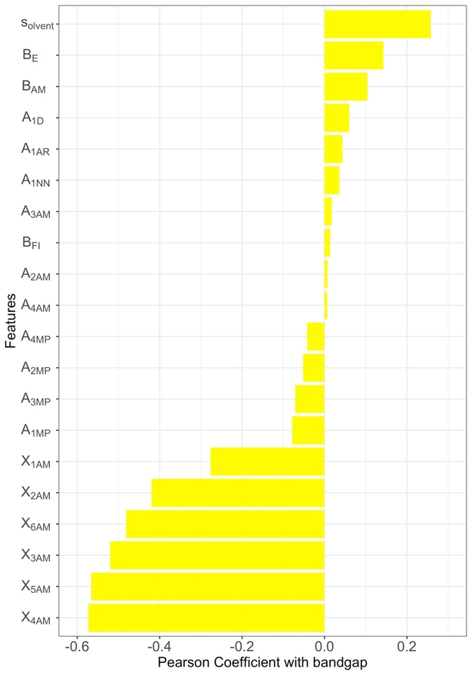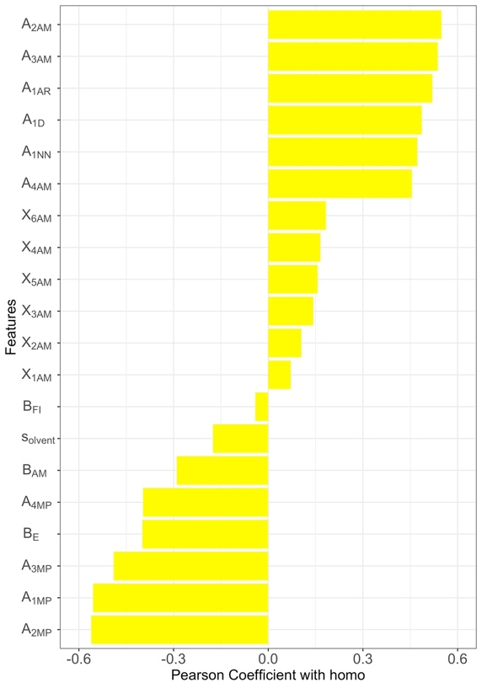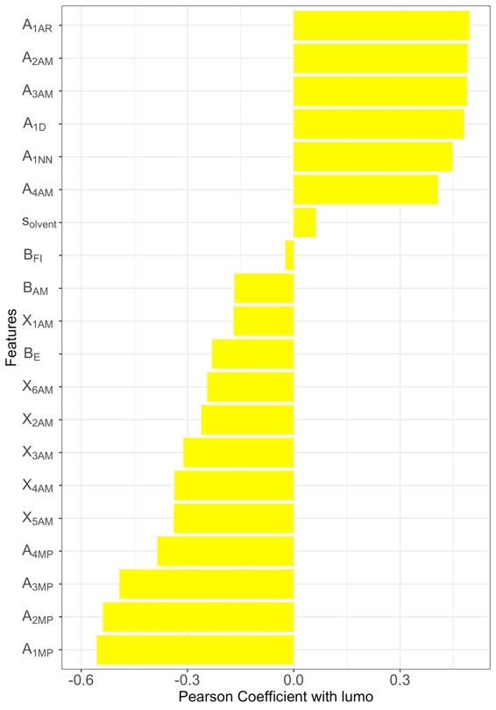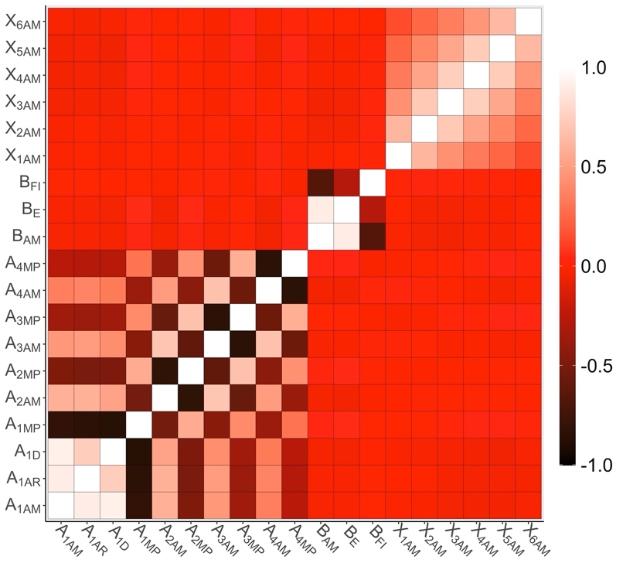

1. 符号回归

分别对归一化后的数据做符号回归

Bandgap

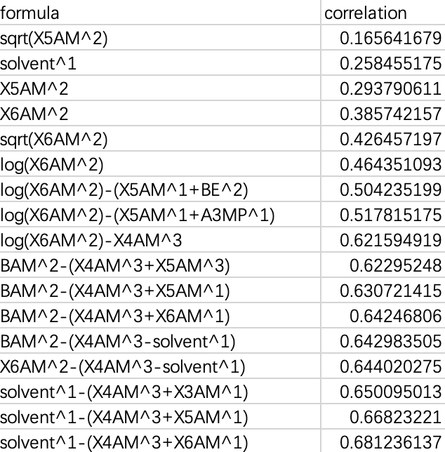

Homo

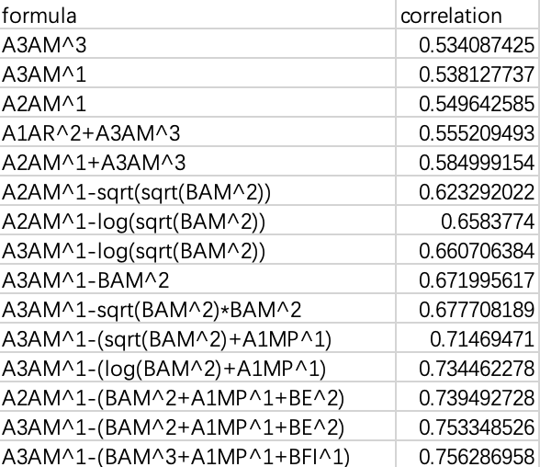

Lumo

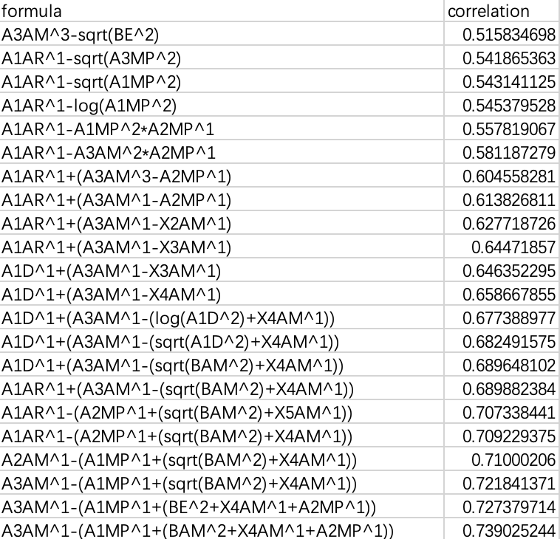

# Conclusion

ACKNOWLEDGEMENTS

This work was supported by the National Natural Science Foundation of China (No. 51702165). The authors acknowledge computational support from NSCCSZ Shenzhen, China.

AUTHOR INFORMATION

**Corresponding Author**

*Email: 002699@nuist.edu.cn.

**Author Contributions**

The author has given approval to the final version of the manuscript.

# References

# Delete